Documentation on RPA

Version Number:1.1

Table of Contents

Introduction: 2

Scope: 2

CI/CD Architecture: 2

Deployment Group: 3

UiPath Studio Pipeline for IPERFORMCollection 7

Pipelines: 8

Tasks: 9

Publish Artifact 9

Triggers:- 9

Validation 10

Release pipeline for IPERFORMCollection 10

Steps: 10

Continuous deployment trigger: 12

Pre-deployment conditions : 13

Tasks: 14

Agent Job: 15

Azure powershell script:Inline Script 16

Copy files – 16

Azure powershell script:Inline Script 18

Variables: 21

Validation 21

Revision History 22

# Introduction:

This is the documentation for the RPA process. It includes the UiPath Studio and release pipeline processes. UiPath Studio pipelines include tasks, artifact generation, etc. Once the UiPath Studio is successful, the release pipeline starts triggering it.

# Scope:

* CI/CD is used because code can be easily deployed into a specific environment in a short period of time.
* Through the UiPath Studio pipeline, we can generate the artifacts, and through the release pipeline, we are able to deploy them in a specific location with the required changes.

# CI/CD Architecture:

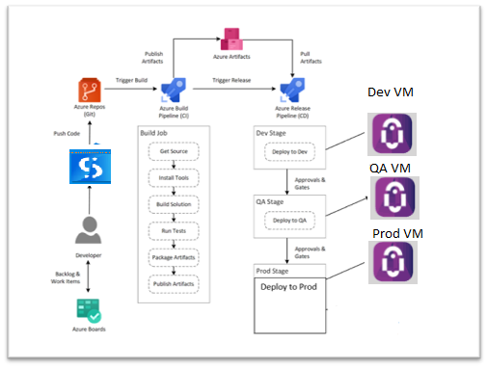

## Deployment Group:

A deployment group is a logical set of deployment target machines that have agents installed on each one.

1. Create a deployment group.

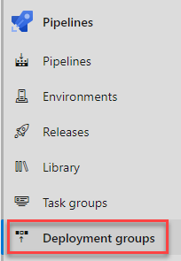

1. Select Add a deployment group

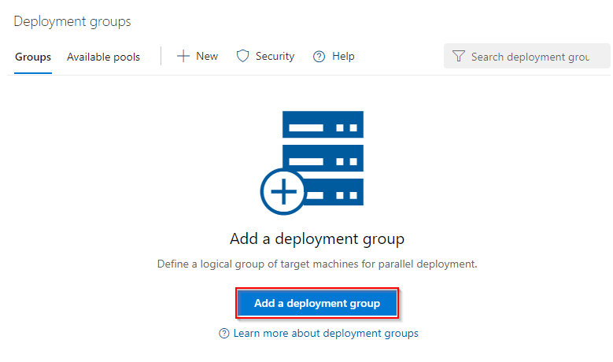

1. Enter a Deployment group name and then select Create. A registration script will be generated. Select the Type of target to register and then select Use a personal access token in the script for authentication. Finally, select Copy script to the clipboard.

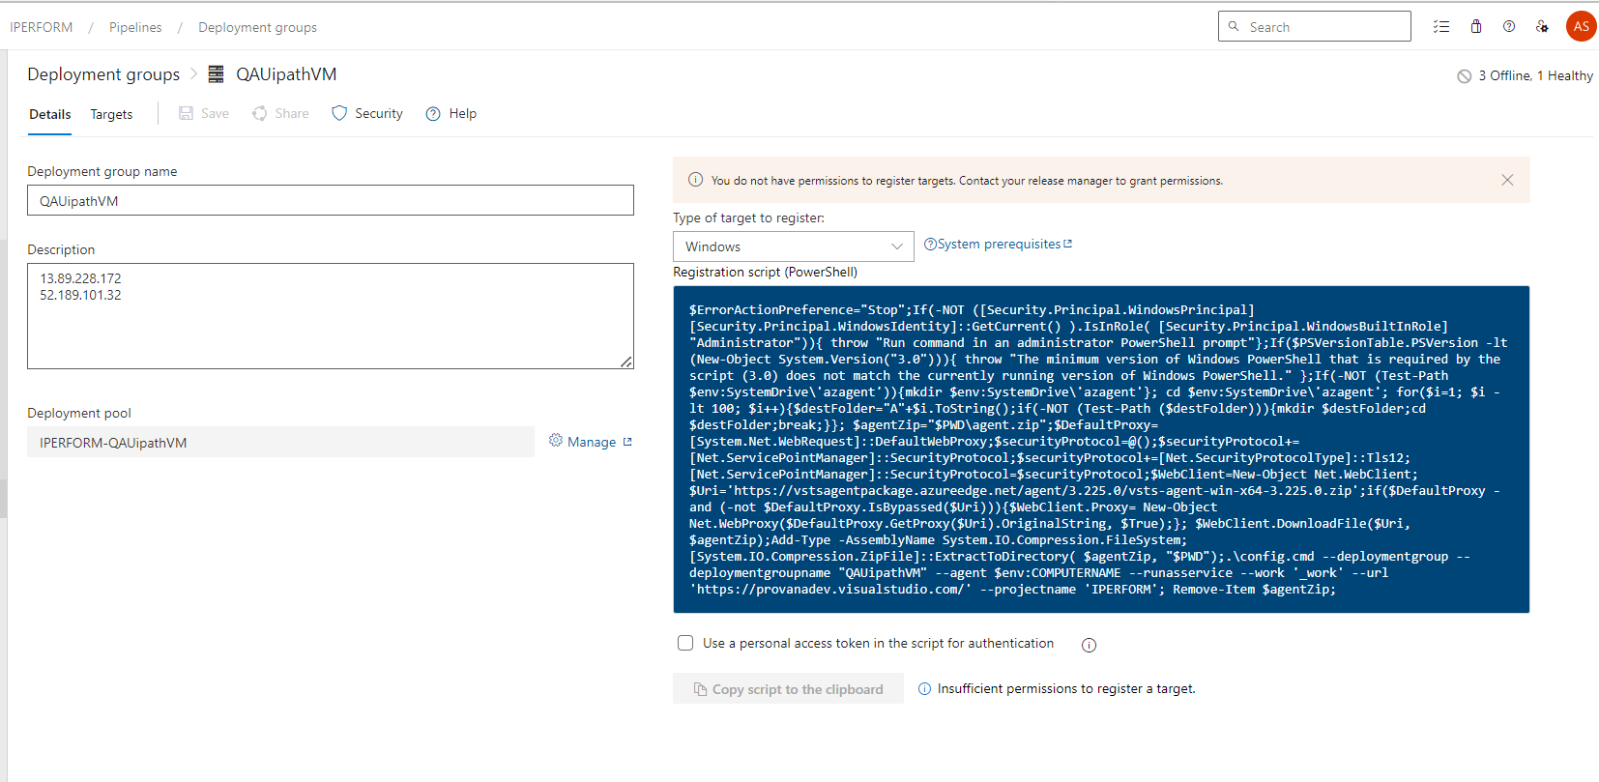

At this stage our deployment group is created but not online yet.

1. Log onto each of your target machines and run the script from an elevated PowerShell command prompt to register it as a target server. When prompted to enter tags for your agent, press Y and enter the tag(s) you will use to filter subsets of the servers.

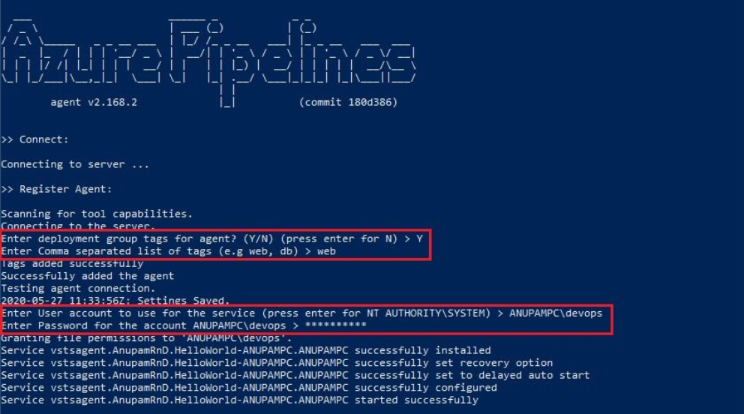

At this stage, our deployment group creation gets completed and now if you go and check the status of the deployment group in the Azure DevOps, it should show as Online.

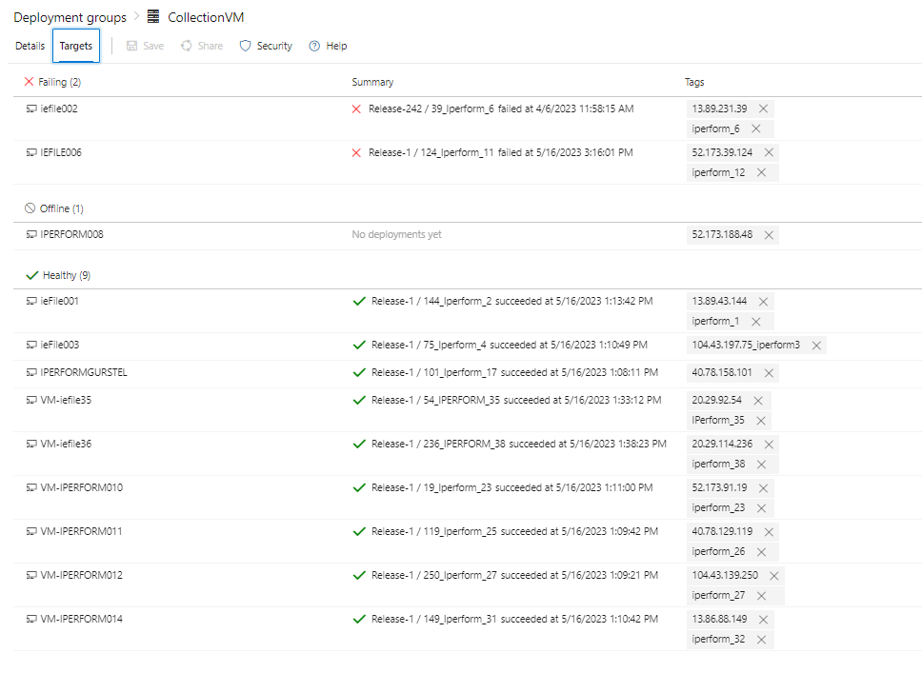

# UiPath Studio Pipeline for [IPERFORMCollection](https://provanadev.visualstudio.com/IPERFORM/_git/IPERFORMCollection?path=/&version=GBDev)

Steps:

1. Graphical user interface, text, application, email

   Description automatically generatedNavigate the page to Pipelines and click on the “New Pipeline”.

2) Click on the “Use the classic editor”.

3) Select the Source as “Azure Repos Git” and followed by Project, Repository and branch.

4)Select the template as “YAML”

## Pipelines:

We are using Azure pipelines (Microsoft hosted agent) as the agent pool for this pipeline. Microsoft-window-latest OS version will be used in the agent.

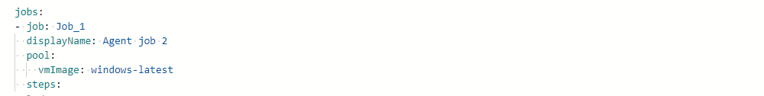

### Tasks:

### Publish Artifact

Publish Artifact is necessary for an automated deployment. This step publishes all the files which you want to deploy later in the release pipeline.

### Triggers:-

# Validation

So, here “drop’ folder should include the following files:

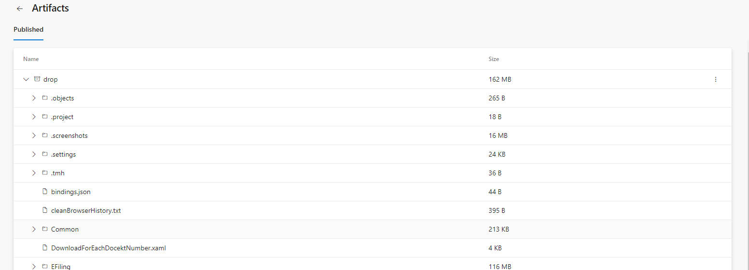

Release pipeline for IPERFORMCollection

## Steps:

1) Navigate to release pipelines and click on “New “so as to create a new release pipeline which will be IPERFORMCollection in this case.

2) Select an empty job because we need to add customized jobs later which will support our project’s needs and functionality.

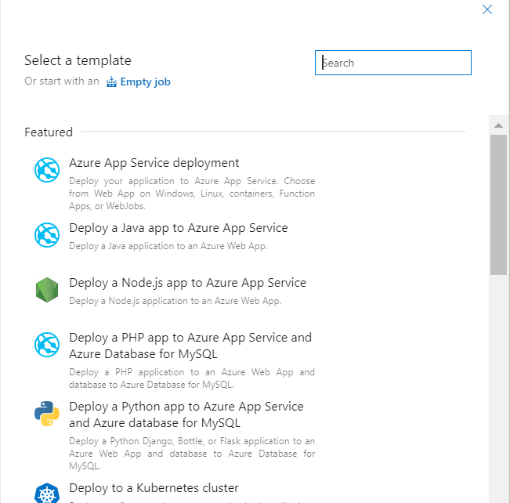

3)Before customizing the jobs, we will need to add the artifact that was built through our UiPath Studio pipeline. So, click on “Add an artifact” and then select the UiPath Studio pipeline which produced the artifact that is going to get used in this release pipeline.

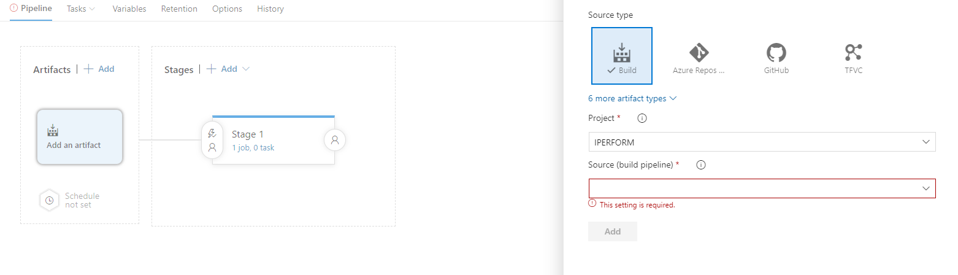

4) As soon as the artifact is added, we must customize jobs according to the functionality of the project.

## Continuous deployment trigger:

Continuous deployment triggers allow you to create a release every time a new build artifact is available.

## Pre-deployment conditions :

Pre-deployment gates ensures there are no active issues in the work item or problem management system before deploying a build to an environment.

## Tasks:

1. We must provide Stage Name, Azure subscription and App type and Name.

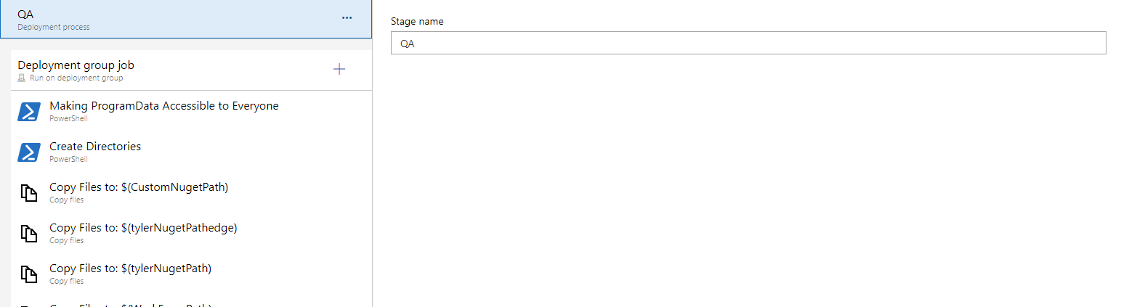

## Agent Job:

A job is a logical grouping of tasks that defines the runtime target on which the tasks will execute. An agent job executes tasks on an agent in an agent pool.

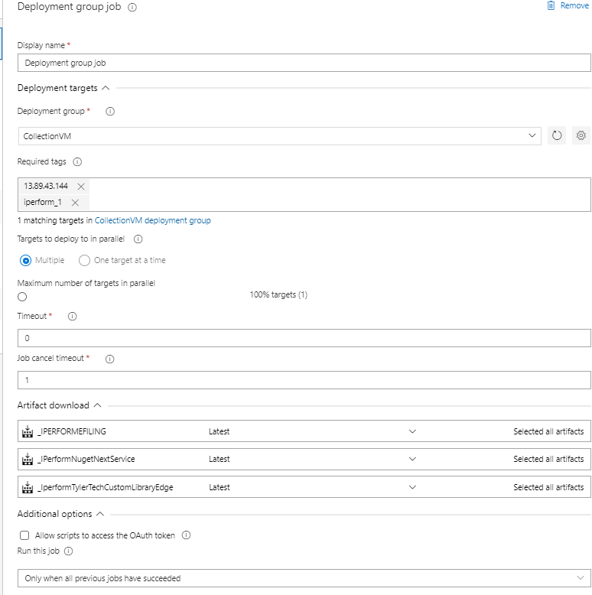

## Azure powershell script:Inline Script

The PowerShell task allows you to add PowerShell code directly within the YAML pipeline or execute an existing script in the source repo .

1. Making ProgramData Accessible to Everyone.

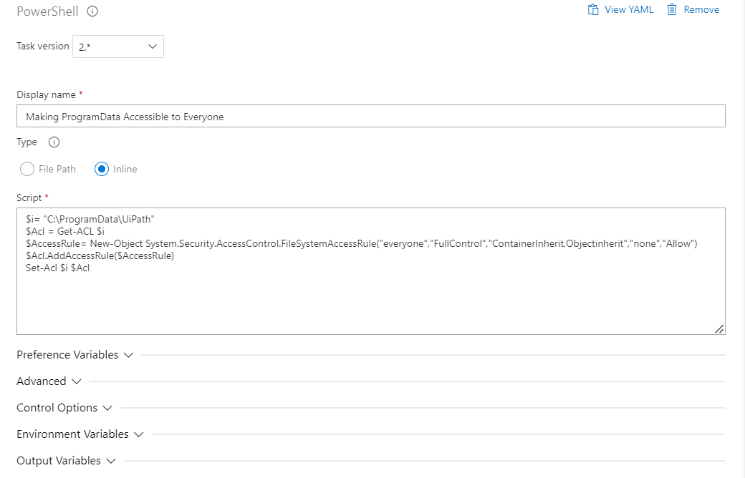

1. Create Directories - This task for creating Directories.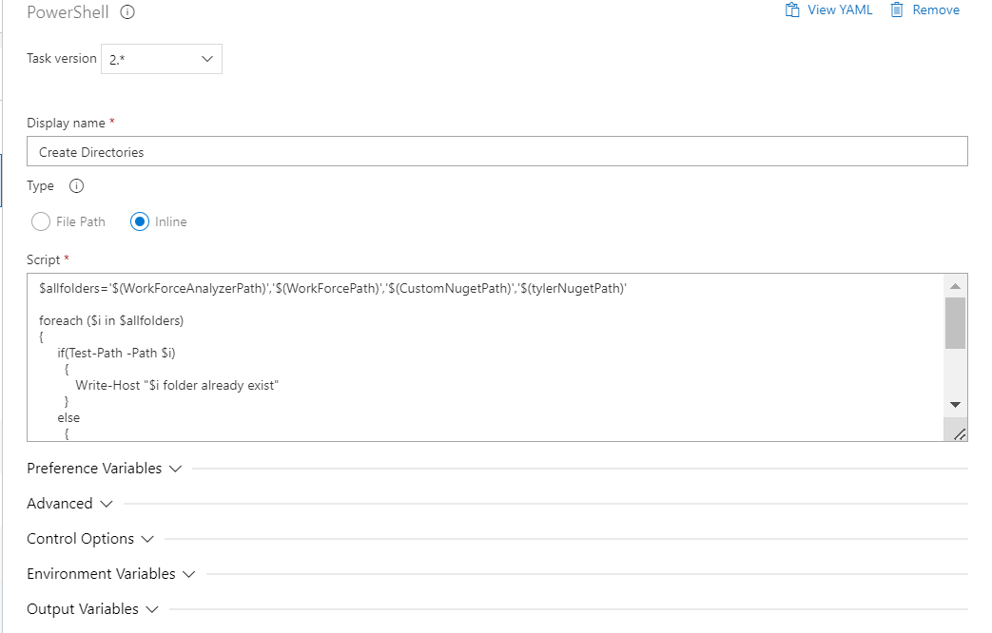

## Copy files –

Copying of files from source folder to target folder. $(system.defaultworkingdirectory) to $(UiPath Studio.artifactstagingdirectory).

1. Copy Files to: $(CustomNugetPath)

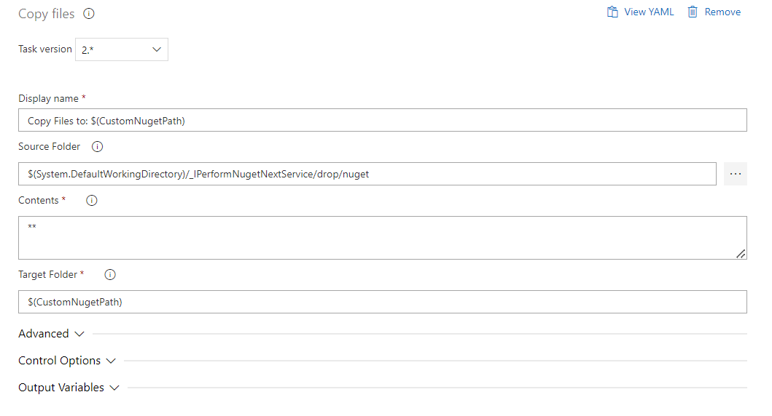

1. Copy Files to: $(tylerNugetPathedge) - This task for copy for source folder to target folder. 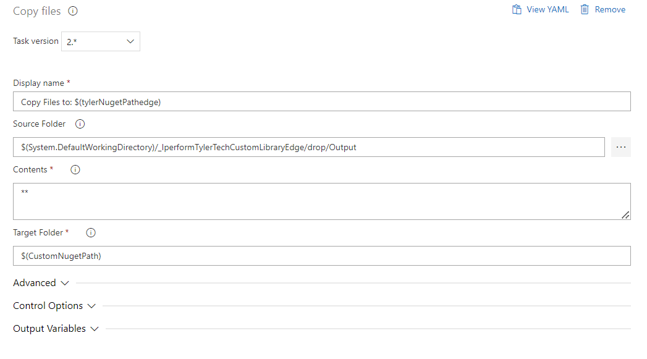
2. Copy Files to: $(tylerNugetPath) - This task for copy for source folder to target folder.

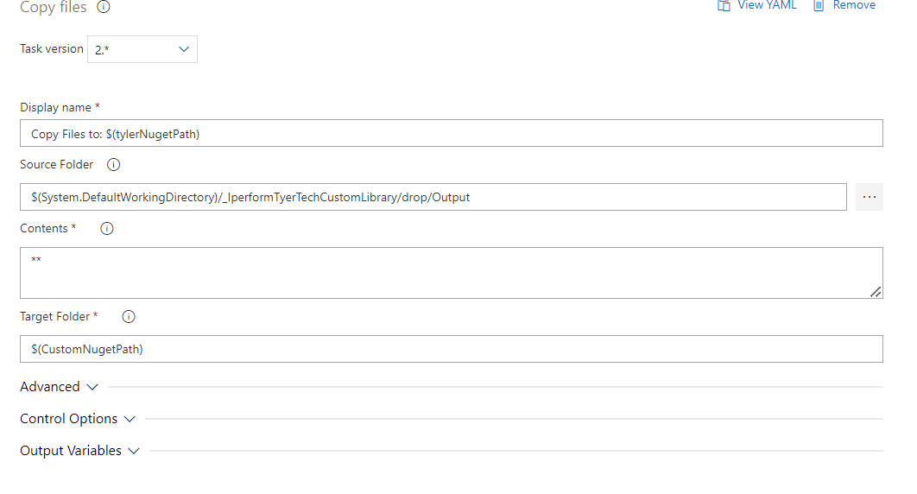

1. Copy Files to: $(WorkForcePath) - This task for copy for source folder to target folder.

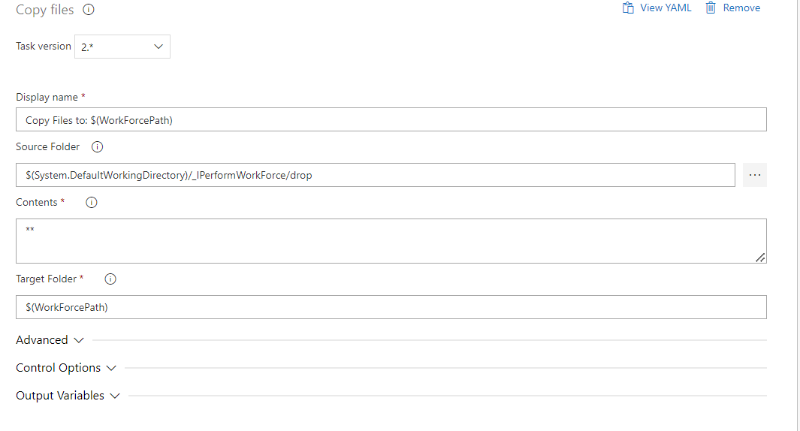

## Azure powershell script:Inline Script

1. Add Package - This task for add package for build numbers.

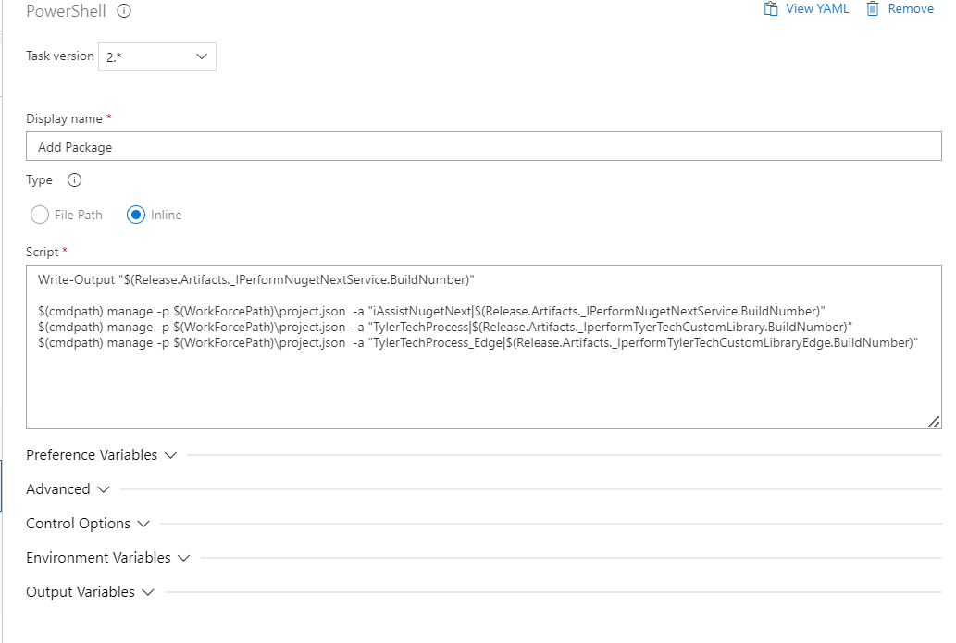

1. Tylerpackage -This task for to connect Tyler website and used for case filling.

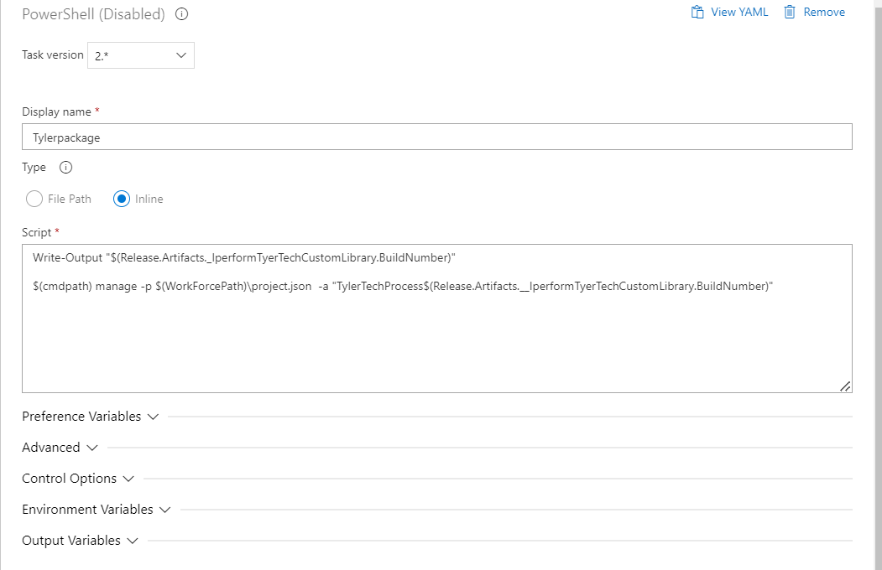

1. Analyse Script - This task for Analysis the Workflow.

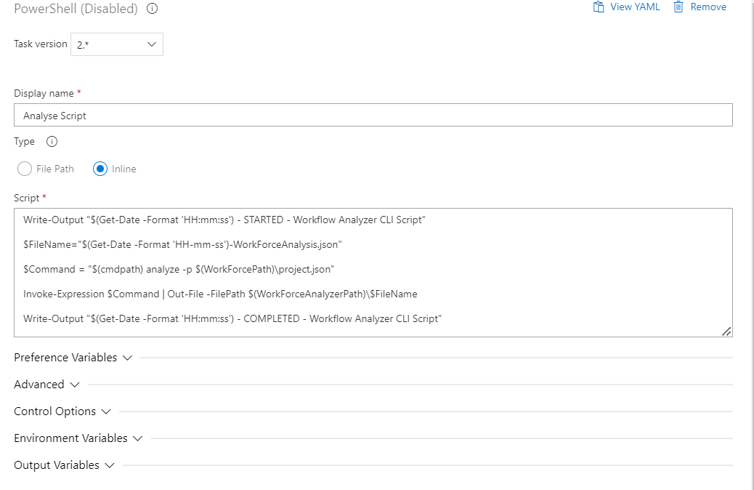

Note :

* Tyler package: not required currently but this is in development may be required later.
* Analysis script: currently disable because Uipath code having lots of warning and error which only effect code quality already informed to dev team once they fix we will enable it.
* delete file: not required now but in case of clean up and deploy we need it.

## Variables:

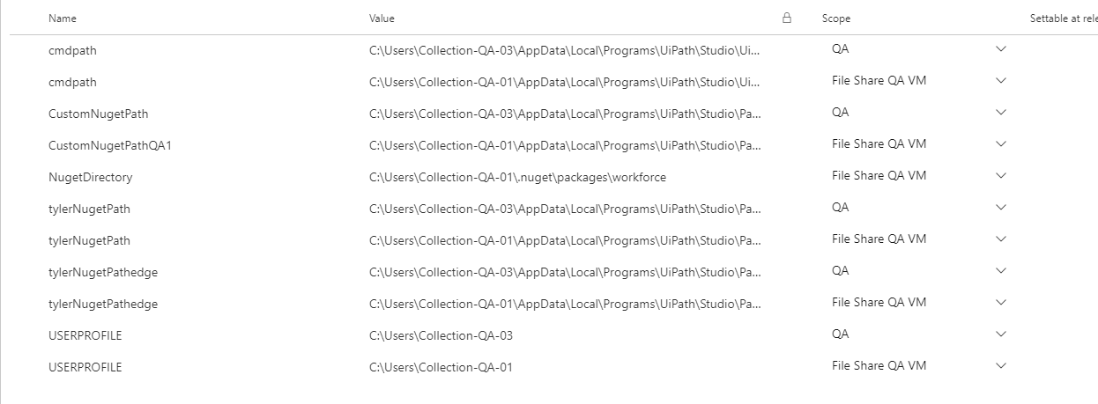

Note: For Stages

* File Share QA VM its containing common vm user’s details .
* File Share QA VM - disable task we will delete later. This stage is required where multiple user present and sharing same file location.

# Validation

# Once the release is successful, NuGet will be available at program data in VM.User will see new or updated version of NuGet in UiPath Assistance.

# 

# Revision History

|  |  |  |  |
| --- | --- | --- | --- |
| **Date** | **Version** | **Description** | **Author** |
| **04/25/2023** | 1.0 | **Draft and Initial** | **Atul Sikarwal** |
| 04/28/2023 | 1.1 | **Review** | Sourabha M |